16.10: As in Example 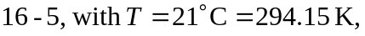

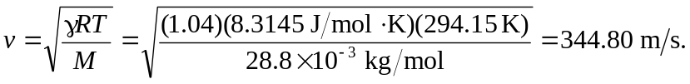

The same calculation with 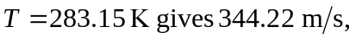so the increase is 